K L UNIVERSITY
FRESHMAN ENGINEERING DEPARTMENT

A Project Based Lab Report On

Air Quality Assessment and Reporting System (AQARS)

SUBMITTED BY:
ID NUMBER NAME
2500032373 J.Meghana
2500032410 Pothuru Vignan
2500032444 Reshwanth Varma
2500032533 Chinthala Charan

UNDER THE ESTEEMED GUIDANCE OF Dr. N. Alangudi Balaji
PROFESSOR



KL UNIVERSITY
Green fields, Vaddeswaram – 522 502 Guntur Dt., AP, India.

DEPARTMENT OF BASIC ENGINEERING SCIENCES



CERTIFICATE

This is to certify that the project based laboratory report entitled “Air Quality Assessment and Reporting System (AQARS)” submitted by J.Meghana, Pothuru Vignan, Munduri Reshwanth Varma N, Chinthala Charan bearing Regd. No. 2500032373, 2500032410, 2500032444, 2500032533 to the Department of COMPUTER SICENCE ENGINEERING , KL University in partial fulfillment of the requirements for the completion of a project based Laboratory in “Python programming (25SC2007)” course in I B Tech II Semester, is a Bonafede record of the work carried out by him/her under my supervision during the academic year 2025 – 2026.

PROJECT SUPERVISOR HEAD OF THE DEPARTMENT
DR. ALANGUDI BALAJI DR. D. HARITHA

ACKNOWLEDGEMENTS

It is great pleasure for me to express my gratitude to our honorable President, Sri. Koneru Satyanarayana, for giving the opportunity and platform with facilities in accomplishing the project-based laboratory report.
We express sincere gratitude to our Director Dr. A. Jagdeesh for his administration towards our academic growth.
We express sincere gratitude to our Coordinator and HOD-BES Dr. D. Haritha for her leadership and constant motivation provided in successful completion of our academic semester. I record it as my privilege to deeply thank you for providing us with the efficient faculty and facilities to make our ideas into reality.
We express my sincere thanks to our project supervisor Dr. Alangudi Balaji for her novel association of ideas, encouragement, appreciation, and intellectual zeal which motivated us to venture this project successfully.
Finally, we are pleased to acknowledge our indebtedness to all those who devoted themselves directly or indirectly to making this project a success.

Name: J.Meghana
Pothuru Vignan
M .Reshwanth Varma
Ch. Charan

ID No: 2500032373
2500032410
2500032444
2500032533

ABSTRACT

The Air Quality Assessment and Analysis System (AQAAS) is a Python-based application used to monitor and analyze air pollution data. It collects pollutant values such as PM2.5, PM10, NO₂, SO₂, CO, and O₃, and calculates the Air Quality Index (AQI) with corresponding health categories. The system uses NumPy and Pandas for data analysis and Matplotlib for visualization. It also provides alerts, trend analysis, and basic forecasting. This system helps users understand air quality easily and supports better environmental awareness.
.

INDEX

S.NO | TITLE | PAGE NO
1 | Introduction | 6
2 | Aim of the Project | 7
2.1 | Advantages & Disadvantages | 8
2.2 | Future Implementation | 8
3 | Software & Hardware Details | 9
4 | Data Flow Diagram | 10
5 | Algorithm for each module | 11
6 | Implementation | 12-13
7 | Integration and System Testing | 14-15
8 | Conclusion | 16

INTRODUCTION
Air pollution has become one of the most serious environmental issues affecting human health and ecosystems worldwide. Rapid industrialization, urbanization, and the increasing use of vehicles have significantly contributed to the rise in air pollutants such as particulate matter (PM2.5 and PM10), carbon monoxide (CO), nitrogen dioxide (NO₂), and sulfur dioxide (SO₂). Monitoring and analyzing these pollutants is essential to ensure a safe and healthy environment.This project demonstrates how programming concepts and data analysis techniques can be applied to solve real-world environmental problems effectively.

AIM

The main aim of this project is to develop an Air Quality Assessment and Reporting System that can analyze pollutant data and determine the air quality level.
The objectives of the system are:
- To collect air pollutant data such as PM2.5, PM10, CO, NO₂, and SO₂
- To calculate the Air Quality Index (AQI)
- To classify air quality into categories like Good, Moderate, and Poor
- To generate a simple and clear report for users

ADVANTAGES
- Provides quick and easy air quality analysis
- Helps in understanding environmental pollution levels
- Reduces manual calculations
- User-friendly and simple to use
- Can be extended with real-time data in future

DISADVANTAGES
- Requires manual data entry if sensors are not connected
- Accuracy depends on correctness of input data
- Limited to small-scale or educational use
- Basic forecasting (not highly accurate like advanced AI models)
- Needs basic knowledge of Python to use/modify
- Not real-time unless integrated with hardware sensors
- Visualization is simple compared to professional tools

FUTURE IMPLEMENTATION

- Integration with real-time air quality APIs
- Mobile app development for easy access
- Graphical representation using charts
- Database storage for historical data
- Alerts/notifications for poor air quality

SYSTEM REQUIREMENTS

SOFTWARE REQUIREMENTS:

- Programming Language: Python
- Operating System: Windows / Linux / macOS

HARDWARE REQUIREMENTS:

• RAM: 4 GB or above
• Processor: i3/i5 or higher
• Basic computer system

DATA FLOW DIAGRAM
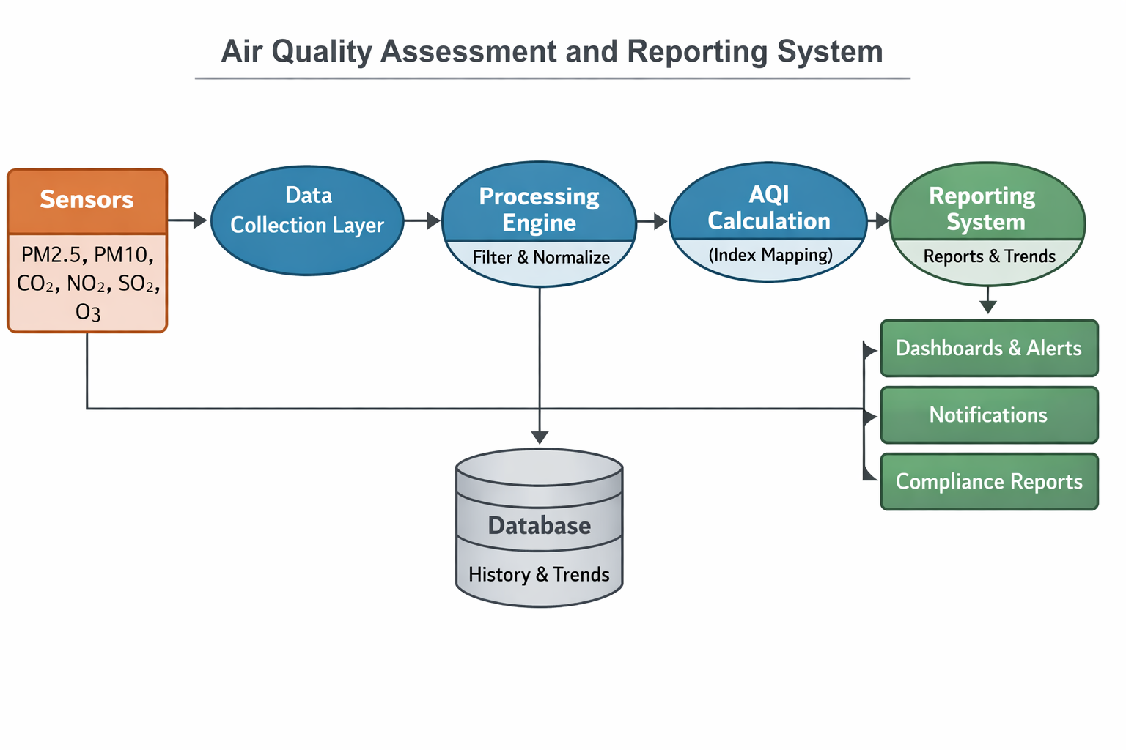

ALGORITHM

Step 1: Start the program

Step 2: Initialize variables and load existing data (if available)
Step 3: Display menu options to the user
Step 4: Read user choice
Step 5: If choice = Add Data
- Enter pollutant values (PM2.5, PM10, NO₂, SO₂, CO, O₃)
- Validate inputs
- Store data with timestamp
Step 6: If choice = View Data
- Display all stored records
Step 7: If choice = Calculate AQI
- Calculate sub-index for each pollutant
- Find overall AQI
- Display AQI category
Step 8: If choice = Analyze Data
- Compute average, maximum, and minimum values
- Identify pollution trends
Step 9: If choice = Visualize Data
- Generate charts (line/bar graphs)
Step 10: If choice = Exit
- Save data to file
- Stop the program
Step 11: End

IMPLEMENTATION

import datetime

# Store data
records = []

# Function to calculate AQI (simple logic)
def calculate_aqi(pm25, pm10, no2, so2, co, o3):
values = [pm25, pm10, no2, so2, co, o3]
aqi = max(values)

if aqi <= 50:
category = "Good"
elif aqi <= 100:
category = "Moderate"
elif aqi <= 200:
category = "Poor"
else:
category = "Severe"

return aqi, category

# Add data
def add_data():
try:
pm25 = float(input("Enter PM2.5: "))
pm10 = float(input("Enter PM10: "))
no2 = float(input("Enter NO2: "))
so2 = float(input("Enter SO2: "))
co = float(input("Enter CO: "))
o3 = float(input("Enter O3: "))

if pm25 < 0 or pm10 < 0 or no2 < 0 or so2 < 0 or co < 0 or o3 < 0:
print("Invalid input! Values cannot be negative.")
return

time = datetime.datetime.now()

aqi, category = calculate_aqi(pm25, pm10, no2, so2, co, o3)

record = {
"time": time,
"pm25": pm25,
"pm10": pm10,
"no2": no2,
"so2": so2,
"co": co,
"o3": o3,
"aqi": aqi,
"category": category
}

records.append(record)
print("Data added successfully!")

except:
print("Invalid input!")

# View data
def view_data():
if not records:
print("No data available.")
return

for r in records:
print(r)

# Analyze data
def analyze_data():
if not records:
print("No data to analyze.")
return

avg_pm25 = sum(r["pm25"] for r in records) / len(records)
max_pm25 = max(r["pm25"] for r in records)
min_pm25 = min(r["pm25"] for r in records)

print("Average PM2.5:", avg_pm25)
print("Max PM2.5:", max_pm25)
print("Min PM2.5:", min_pm25)

# Main menu
while True:
print("\n--- AQMAS MENU ---")
print("1. Add Data")
print("2. View Data")
print("3. Analyze Data")
print("4. Exit")

choice = input("Enter choice: ")

if choice == '1':
add_data()
elif choice == '2':
view_data()
elif choice == '3':
analyze_data()
elif choice == '4':
print("Exiting program...")
break
else:
print("Invalid choice!")
INTEGRATION AND SYSTEM TESTING
OUTPUTS
Screen Shots:

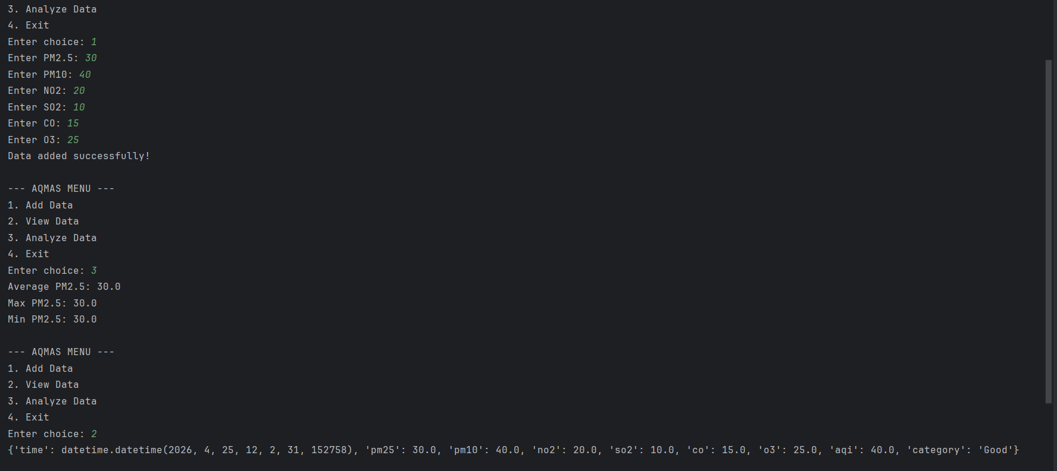

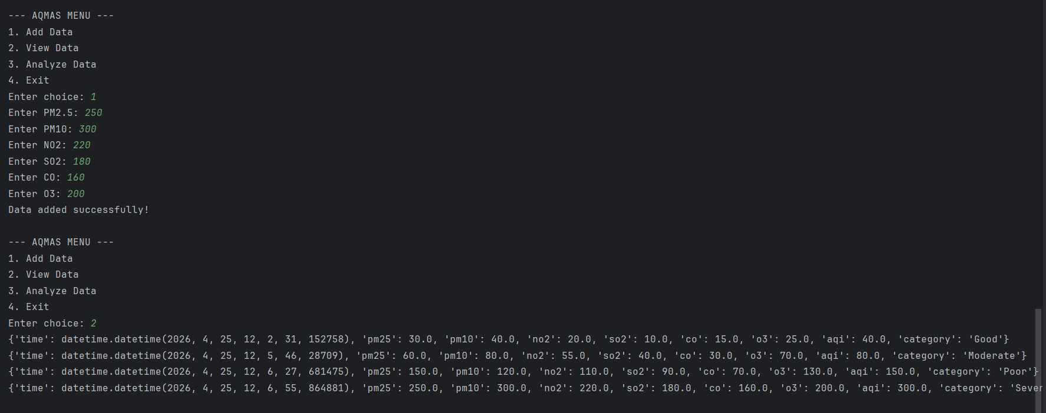

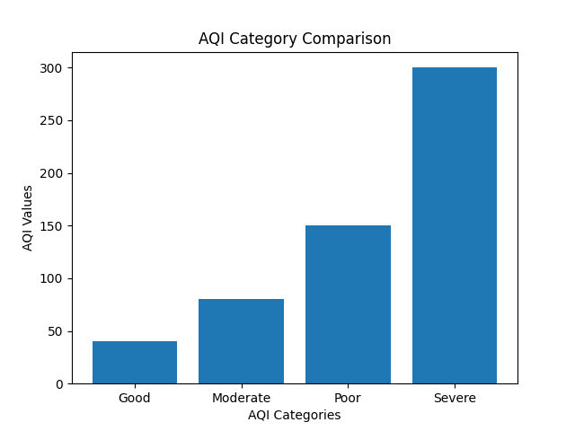

CONCLUSION

The Air Quality Assessment and Reporting System has been successfully developed using Python. The system efficiently analyzes pollutant data and provides meaningful insights into air quality levels. It helps users understand environmental conditions and take necessary precautions.This project demonstrates how simple programming techniques can be used to solve real-world environmental problems. With further improvements such as real-time data integration and graphical visualization, the system can be made more powerful and practical.

